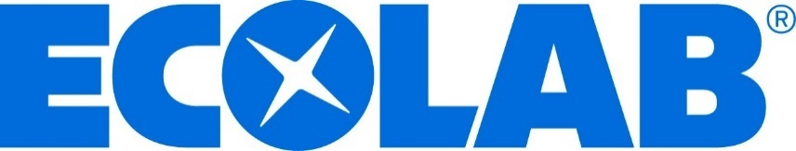

CLEANING, SANITIZATION AND
FOOD SAFETY
PARTNERSHIP PROPOSAL

FOR

Lugano Resort and Spa

Ecolab Vietnam Co., Ltd.

8th FLOOR, UNIT 8.2
364 CONG HOA STREET, ETOWN 2, HCMC, VIETNAM
www.ecolab.com



17th November, 2025

To: Ms. Quyên Lý – Representative of Lugano Resort and Spa,

Dear Ms. Quyen Ly,

I would like to thank you for the opportunity to present a program designed to help keeping your operation cleaner, safer, healthier and deliver better business results in a sustainable way. Our focus on service, commitment to innovation, and dedication to providing comprehensive solutions makes us a partner you can count on everywhere it matters.

Ecolab understands that the overall cost of clean is important to our customers. Your program has been specifically developed to offer our most tested and the industry’s most reliable service, cleaning and sanitation chemistry available. The program included in the attached proposal helps optimize cleanliness, sanitation, labor, and utilities.

These recommendations herein are specifically designed to provide the great cleaning results at a low overall cost while standardizing your cleanliness and sanitation program throughout your operation.

I look forward to hearing from you soon.

Sincerely,

Thanh Nguyen (Antonie)
Territory Manager, Vietnam Institutional

ECOLAB Tower B, Viettel Complex Tower, Unit 23.02B, 285 Cach Mang Thang Tam ST, Ward 12, District 10, HCMC
M +84(977)883-330 E manhthanh.nguyen@ecolab.com

Sustainability at
ECOLAB



- Partner with customers to tackle complex economic and environmental challenges, sustainably.
- Help companies across more than 40 industries do more, with less.
- Look at the total impact of our solutions and operations to minimize environmental impact.
- Operate responsibly with a commitment to continuous improvement

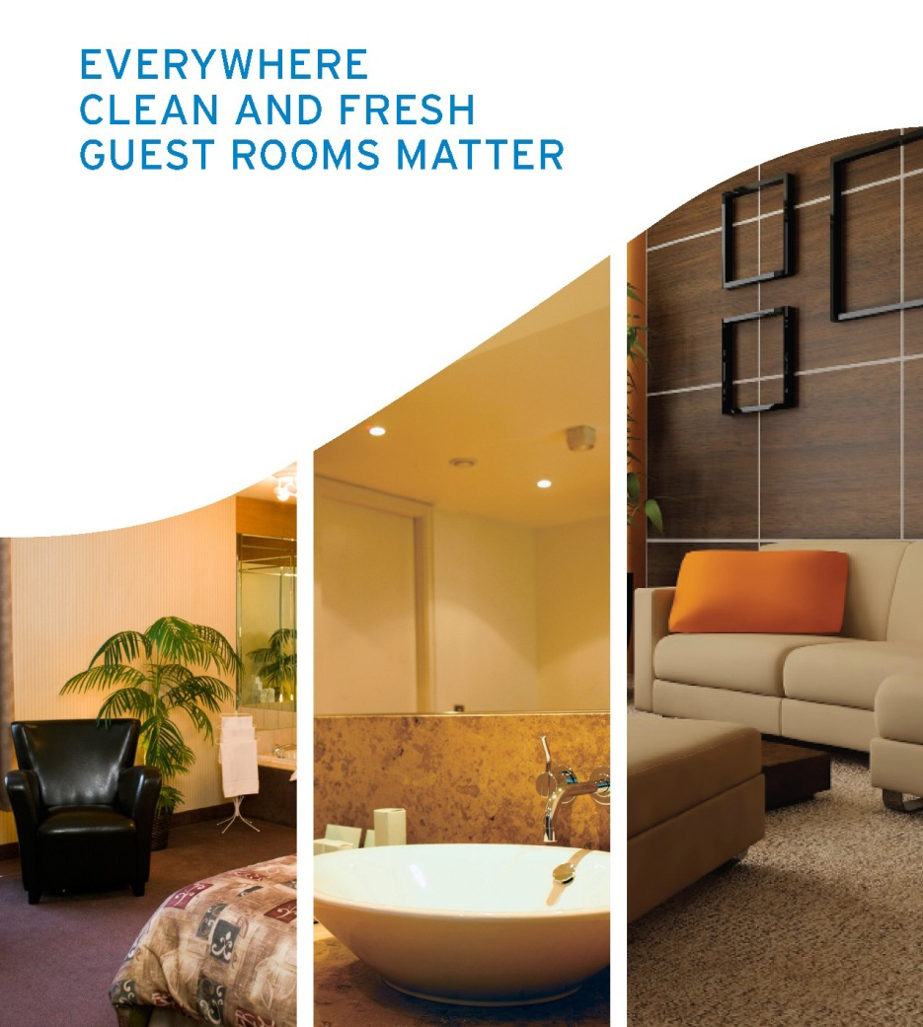

GUEST ROOM & FRONT OF THE HOUSE PROGRAM

Your Business, Your Brand. Are Important to us!

Delivering an exception experience for your guests, enhancing business performance, and embracing sustainable practices are all key to today’s business success.

Ecolab delivers solutions for your Peace of Mind and meet your goals
- Ecolab provides Solutions to deliver Sparkling Clean
- Fresh Start program with our Sustainable Service Approach
Ecolab Solutions:

- High Performance Concentrated Solutions
Ecolab provides patented, environmentally responsible concentrated products delivering excellent results with lowest costs per cleaning over ready-to-use products

- Cleaning Tools
Optimize results with the right labor-saving tools to help staff clean with less effort

- Smart Dispensing Technology
The most comprehensive, user-friendly dispensing system on the market. The Oasis Pro™ dispenser equips your cleaning team with state-of-the-art technology to help make the job safe, easy and economical
Improved
Operational Efficiency
Increased
Cleanliness Scores
CO Consistent Housekeeping Result

- Service & Training
Ecolab consultative approach (train your staff to the RIGHT Process and Product Levels, balancing, chemistry and regular service calls), delivers sparkling clean results at the best possible lower overall operating cost

Public Room Cleaning Process
Guest Room Cleanig Process

Keep Your Operation Sparkling Clean & Your Guest coming back is important
Ecolab can help to meet your goals
Carpet & Upholstery Spotting
Biohazard & Incident Cleanup

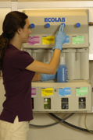
Housekeeping Service Procedures

Personally, Delivered Service

Service Commitment
- On call 24 Hours a Day, 7 Days a Week

Housekeeping Procedures for Ecolab Representative
- Check in with Executive Housekeeper/General Manager for any problems between calls and for new employees that need training on Ecolab areas of responsibility.

Results Inspected
- The Ecolab Representative will inspect housekeeping results which may include: floors, entry area, employee restrooms, guest restrooms, and hallways.

Dispensing Equipment Inspected
- Ecolab Representative will inspect all dispensing equipment to ensure proper function and concentrations.

360º of Protection – Operational / Potential Safety Areas Inspected
- Ecolab Representative will inspect operational areas and potential safety areas which may include:
■Eye Wash Station  ■Biohazard Kit  ■First Aid Kit | ■Floors  ■MSDS Station  ■Inventory | ■Wall Charts  ■Spray Bottles | ■Labels  ■Test Strips

- All issues identified and services provided will be detailed on a Service Detail Report. The Ecolab Representative prior to leaving will make required adjustments, corrections or repairs or make arrangements for them. Service reports will be reviewed electronically and signed by the Manager with all action needed agreed upon. A copy of the report will be faxed or e-mail the following day.

Bio-Based
GUEST ROOM & FRONT OF THE HOUSE PROGRAM

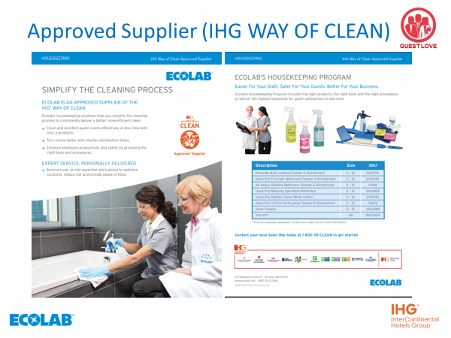

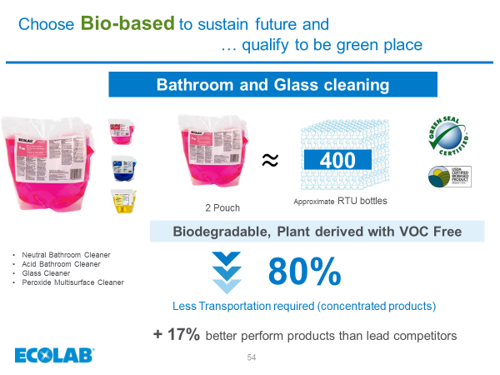

CUSTOMIZED TRAINING

Your Business, Your People. Are Important to us!

It is critical to have knowledgeable and informed employees. A successful training program can provide your employees with the information they need to work efficiently. When this is accomplished, it will have a direct impact on your customer retention and profit margins.

Ecolab understands the importance of providing effective training programs. We will commit to providing every resource we have available to you and your management teams for this purpose. Below is a summary of some of the different categories our field specialists concentrate on :

On Going Training Program
Housekeeping Department | Kitchen Department | Laundry Department
Chemical Application & Safety | Chemical Application & Safety | Chemical Application & Safety
Washroom Training Program | Warewashing Handling and Cleaning Procedure | Launder-Care
Clean-Care | Ecolab Safesteps – Foodborne Illness prevention steps

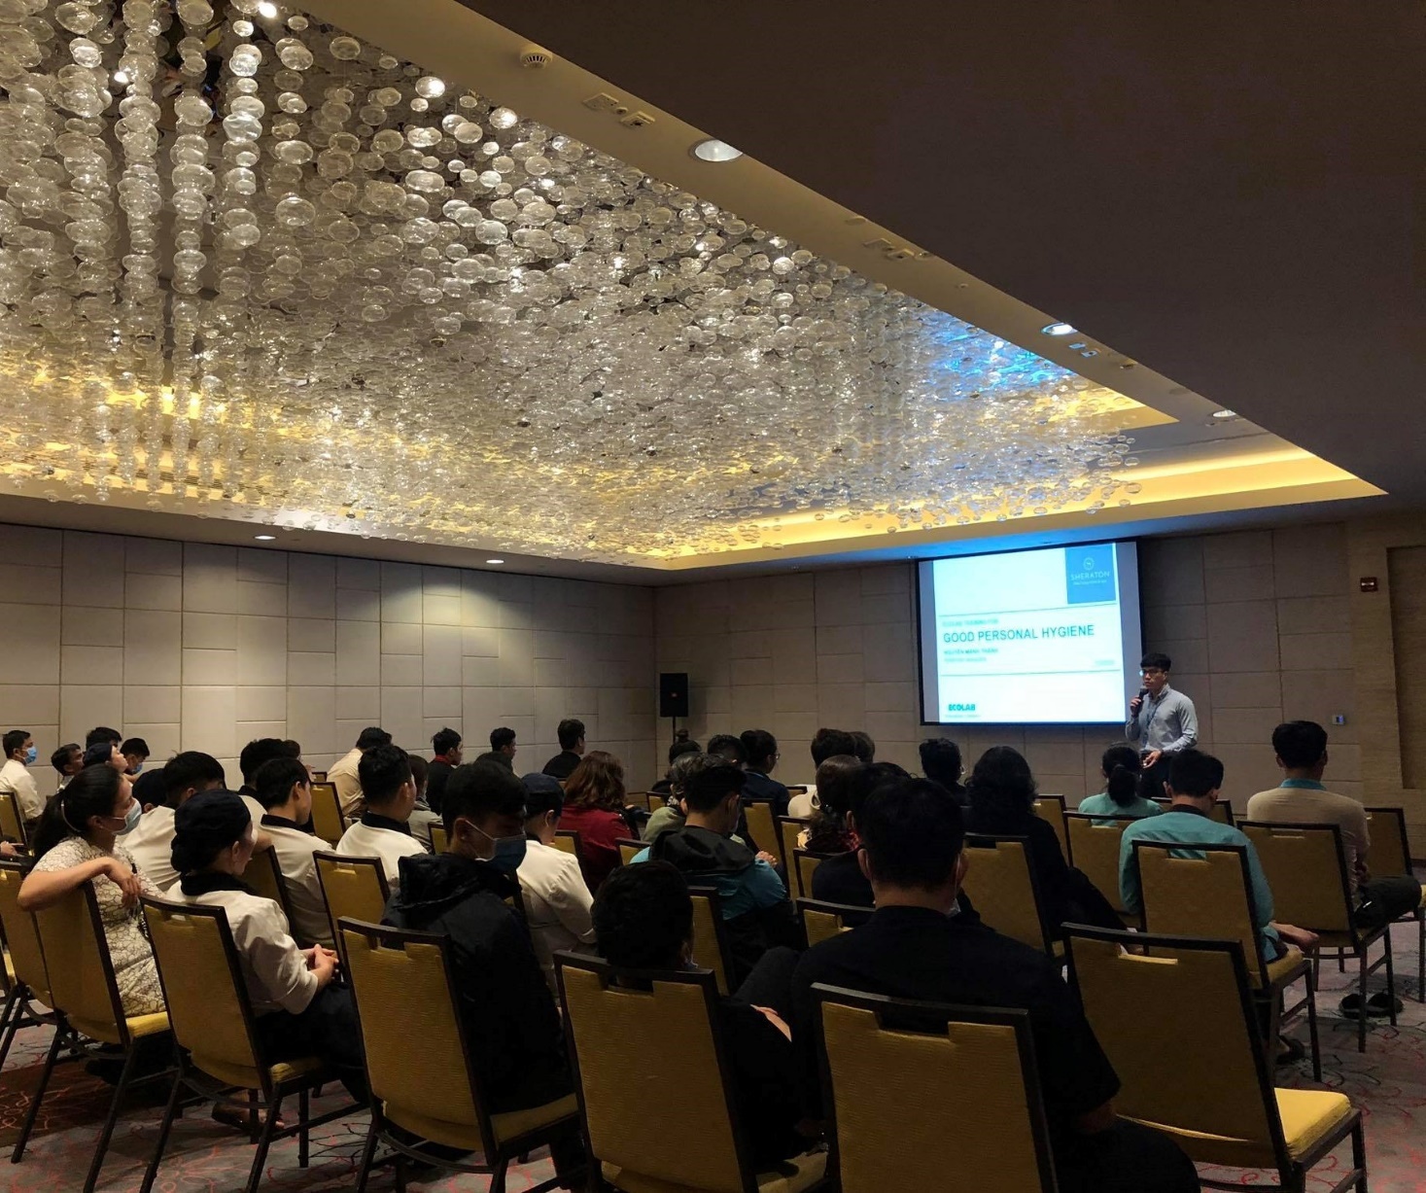

SERVICE AND SUPPORT COMMITMENT

Department | Activities | Frequencies
Laundry Regular Service | - Check all equipment  - Check wash formula, time, water level and temperature  - Measure alkaline, chlorine, oxygen and iron content  - Check washing results  - Check inventory level and suggest level for replenishment  - Present a written service report for Laundry Manager on completion of each service call | Monthly
Housekeeping Regular Service | - Check results and dispenser conditions  - Check cleaning procedures  - Check carpet cleaning results, floor cleaning results  - Present a written service report for Executive Housekeeper after completion of each service call | Monthly
Around the clock 24 Hours Support Service | - Our system based approach skilful united products and services, the most technologically advance equipment, and comprehensive training and support by a Team of Technical Support staff ready to serve you 24-hours a day, seven days a week | 24/7
Operating Cost Monitoring | - Calibrate product dosage to its optimum and to be adjusted  - Report on any improper handling and undertake immediate rectifying actions to ensure no wastage, misuse and potential hazard to employees  - Compile detailed consumption report for Management | On Going
Executive Review | - Foster closer linkage between Ecolab and your Management  - Keep Management inform of overall costs and results  - Seek for continuous improvement based on our findings and area to be improved | Quarterly
Training | - In-Service Training by an Experienced Ecolab Specialist  - Safety Standards  - Equipment Usage  - Employee, Food Safety Program/CleanCare/Launder to Standard Program  - Instructional Wall Charts | Start Up & On Going

G 360 E – SERVICE REPORTS

Your Business, Your Brand. Are Important to us!

Ecolab understands the need for smooth running of customers operations and provide proactive services.

Ecolab Service Reports will be presented to your Management and highlight operational factors requiring action such as manpower requirements, product usage, waste and justification for future capital investments.

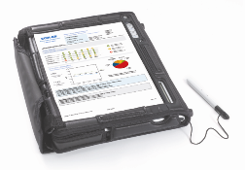
These reports include a complete checklist on all critical areas of the stewarding, housekeeping and laundry operations.

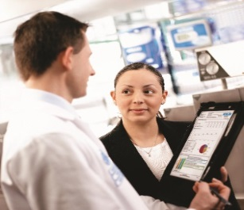

All issues identified and services provided will be detailed on the Service Report. The Ecolab Representative prior to leaving will make required adjustments, corrections or repairs or make arrangements for them. Service reports will be reviewed electronically and signed by the Manager with all action needed agreed upon. A copy of the report will be faxed or e-mailed the following day.

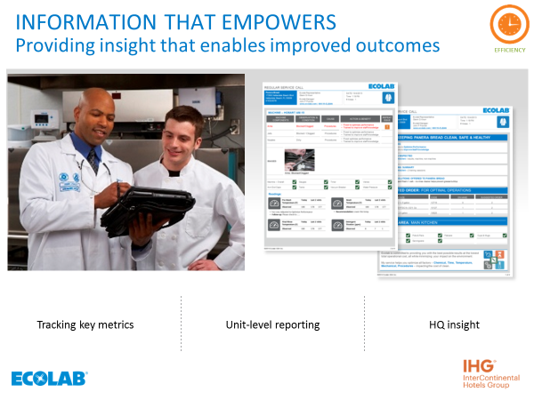

EMERGENCY SERVICE COVERAGE

Your Business, Your Brand. Are Important to us!

Ecolab understands the need for smooth running of customers operations hence we provide 24x7, 365 days of service.

- Telephone follow-up on emergency service requests
- Escalation process to help insure timely issue resolution
- Technical support provided by world-class chemists, microbiologists and engineers

BUSINESS REVIEWS

Your Business, Your Brand. Are Important to us!

Ecolab will conduct regular Business Review with your management, with the objective to evaluate and continually improve upon the services we provide to your property. As a partner in sanitization and hygiene we will discuss Ecolab regular services and support, including any current issues. We will also look at any cost saving initiatives that we have found to be of benefit to the hotel and provide a comprehensive Quality Overview. This will include chemical consumption, service report and potential water and energy savings. During the review our team of specialists will offer suggestions that we believe will compliment your sanitization and hygiene objectives.rstands the need for smooth running of customers operations and provide proactive services.

IMPLEMENTATION PLAN

Your Business, Your Brand. Are Important to us!

Ecolab will work with you and your team to develop an implementation plan that incorporates the following Steps.

- Review and confirm product selection, KPI’s and training plan

- Meet with all relevant parties to review plan.

- Prepare MSDS, risk assessments, par inventory levels, training and service details.

- Meet with engineering and department heads to confirm scope of works and initial training.

- Survey all areas for installation and training requirements.

- Document installation times and training schedule for sign off by your key management.

- Manage installations and return all full or part drums to the dock for collection, in the case where product cannot be returned Ecolab will manage their use in a cost effective manner so as not to cause financial inconvenience.

- Conduct initial training and set a plan for all ongoing training.

- Walk through with nominated representatives for a sign off by outlet.

- Implement schedule service regime.

- Conduct initial business reviews Revision and sign off would require after each and every phase.

PROGRAM TERMS*

Your Business, Your Brand. Are Important to us!
This program is offered upon successful Business Partnership between Ecolab Vietnam Ltd. and Lugano Resort and Spa Exclusive Supplier for its Ware-washing, Housekeeping Operations.

a The Business Partnership Contract Period shall be Three (3) Years with an option for renewal of One (1) year at same terms and condition

b The price quoted herein (Appendix 1, 2) remains protect for 12 months from date of Partnership Agreement; thereafter a new pricing structure for the products will be reviewed annually based on mutual agreement. The price adjustment will be agreed with both party between Ecolab and Lugano Resort and Spa and will inform one month prior if any adjustment.

Appendix 1  Appendix 2  Appendix 3 | Chemical Quotation – Housekeeping / PA  Chemical Quotation – Kitchen / FnB  FOL equipment

c Upon successful partnership Ecolab shall provide following investment and sponsorship during the tenure of partnership

No | Description
1 | 8.7% Net Refund (8.7% local rebate) Within 90 days following the end of the year, Ecolab will pay Customer a yearly net refund equal to 8.7% of the price paid for Products purchased directly from Ecolab or an Ecolab-authorized distributor
2 | FOL equipment for all chemical pantries.
3 | Spray bottles (support 01 time) – 100 pcs. Total: $600
4 | Training program every year

PROGRAM TERMS* - Continue

Appendix 1 | Chemicals Pricing – Housekeeping / PA

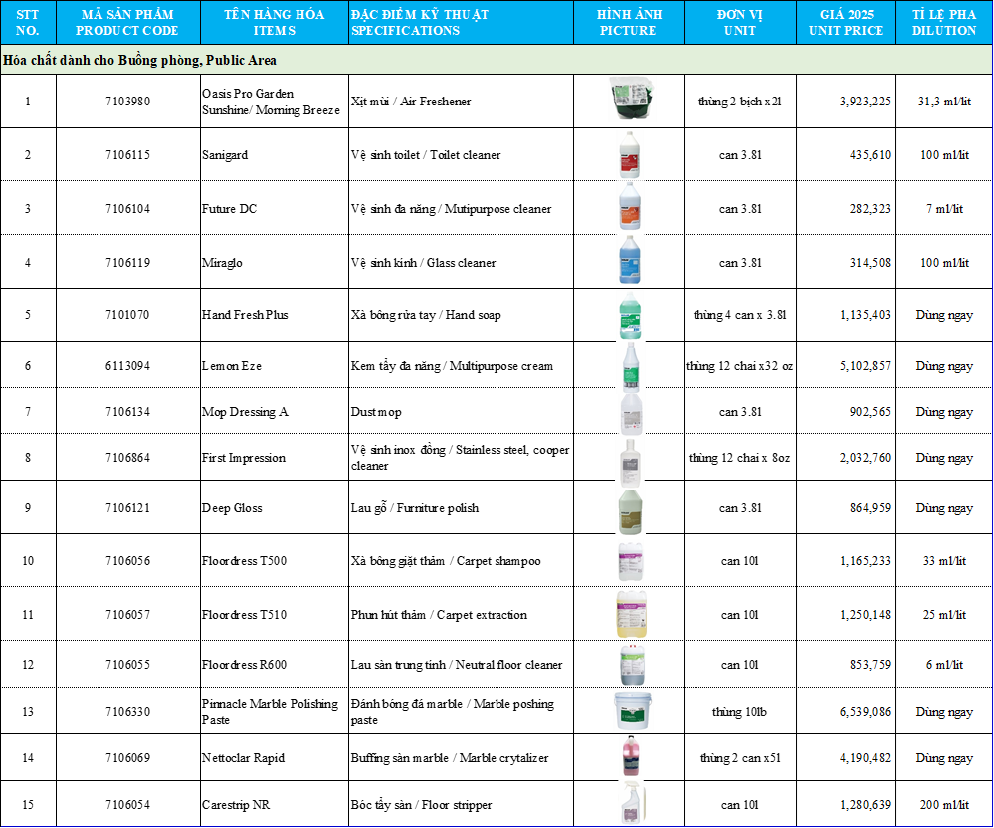

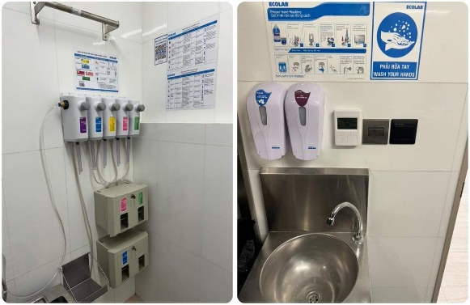

Appendix 2 | Chemicals Pricing – Kitchen / FnB

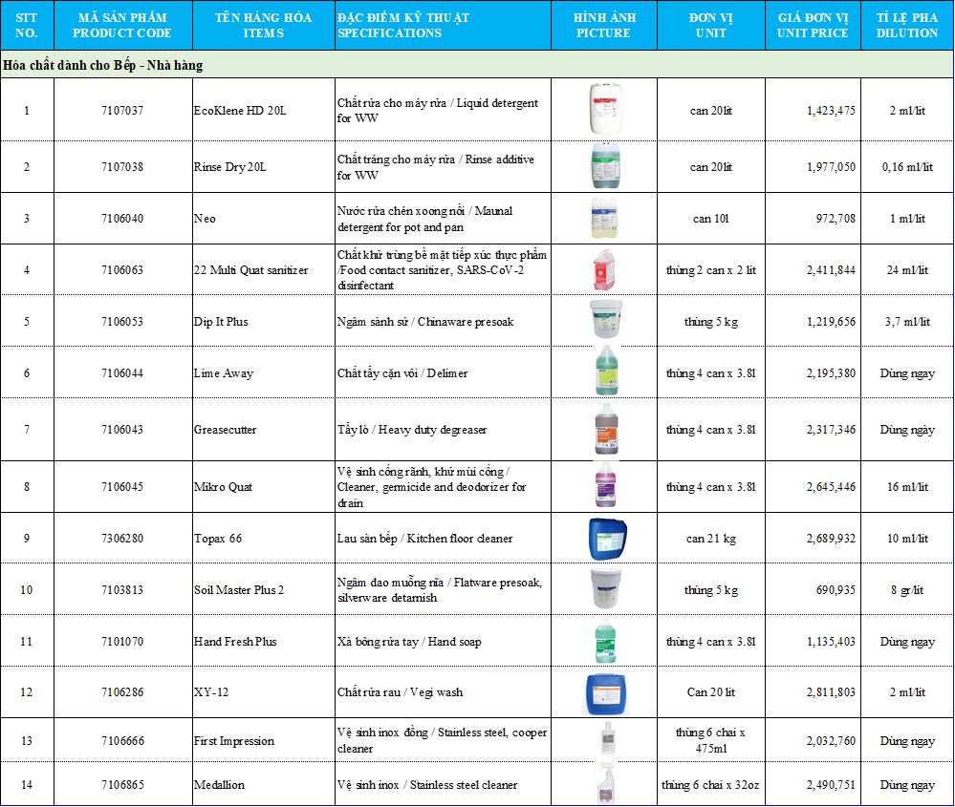

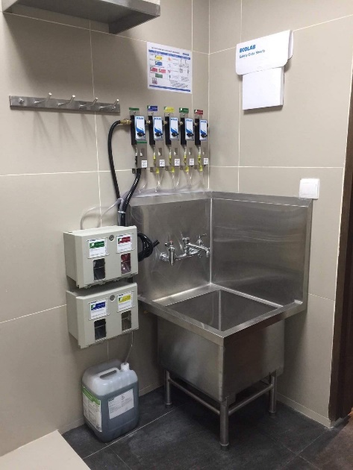

Description | Image | Unit Price | Note
Dispenser for Warewashing | 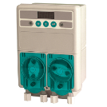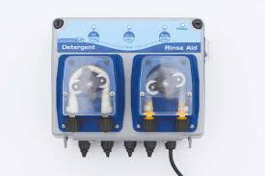 | FOL | Kitchen, FnB
Wall dispenser (USA) – Pro Ultra 1 / Prosink | 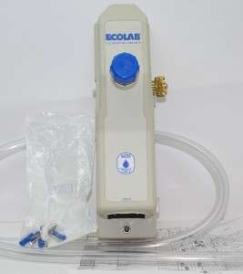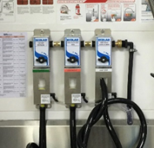 | FOL | Kitchen, FnB, House Keeping
Spray Bottle (Thailand) | 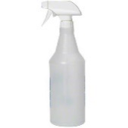 | FOL | Kitchen, FnB, House Keeping
Hand soap dispenser (Thailand, Viet Nam) | 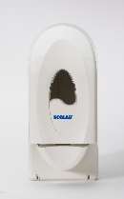 | FOL | Kitchen, FnB, House Keeping
Appendix 3 | FOL equipment

*All dispeners and utilities are FOL, on demand.

Activities | at Customer site

Activity | Picture | Description | Note
Dispenser installation | 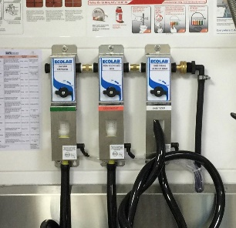 | 3 compartment sinks: clean, rinse and sanitation | Wall-chart and usage notice.
Hand washing | 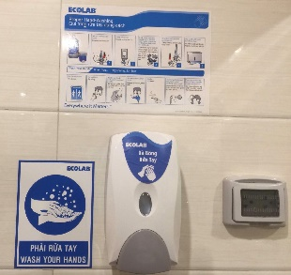 | Food safety: hand washing procedure, Hand soap dispenser, Hand washing notice | Every hand-washing‘s sink
MSDS | 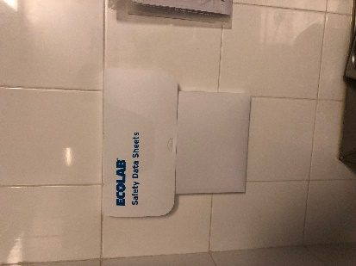 | Ecolab holder with updated Safety Data Sheet (SDS) | Every Ecolab station
Vegi sanitation check | 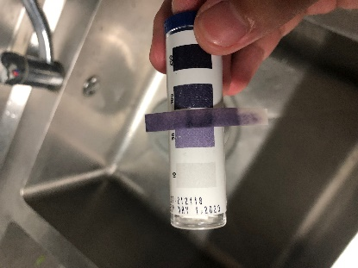 | Checking vegi sanitation’s concentration at every service call (Ecolab XY-12 chemical) | Recommended concentration 25-50ppm.
Har surface sanitation checking | 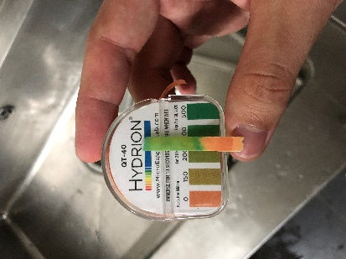 | Checking the concentration of QAC based chemical (Ecolab 22 Multi Quat Sanitizer) at every service call | Recommended concentration 150 – 400 ppm.

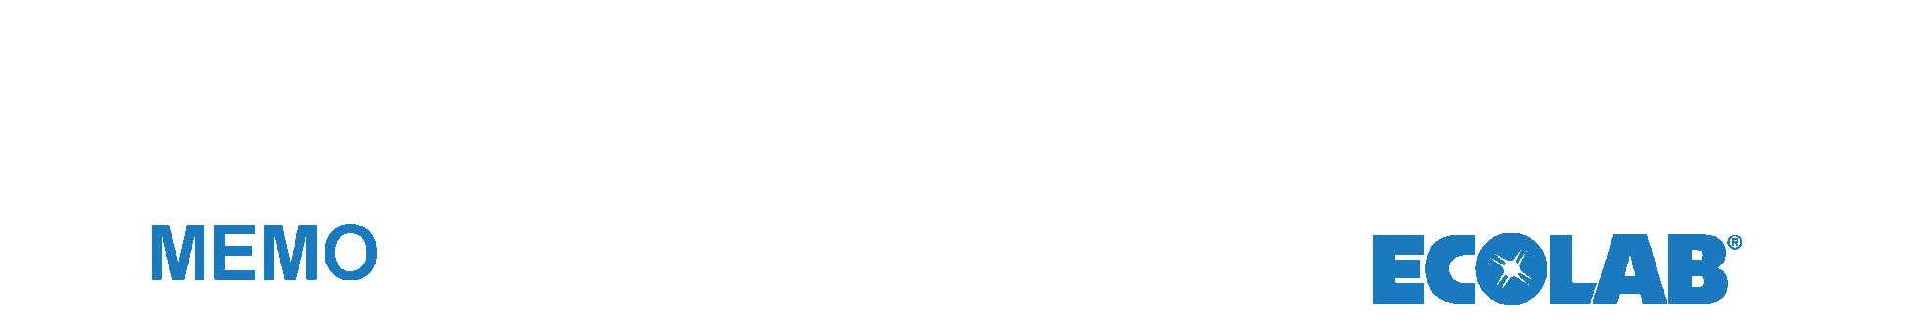
ANNEX

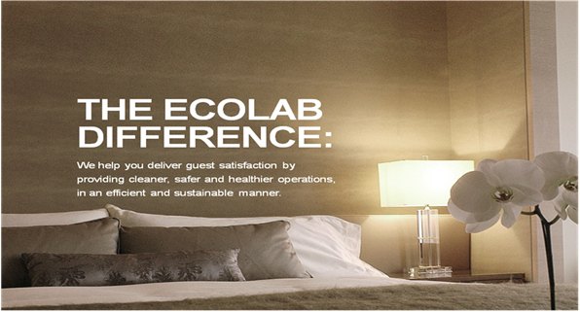

COMPANY OVERVIEW

From its founding in 1923, Ecolab’s story has been one of innovation, customer service, industry leadership and growth. Over the years, we have built upon our humble beginnings – one man transforming a simple idea into a simple product to cost-effectively clean hotel carpets – to become a global company with 40,000 employees serving more than one million customers across a range of industries in more than 160 countries.
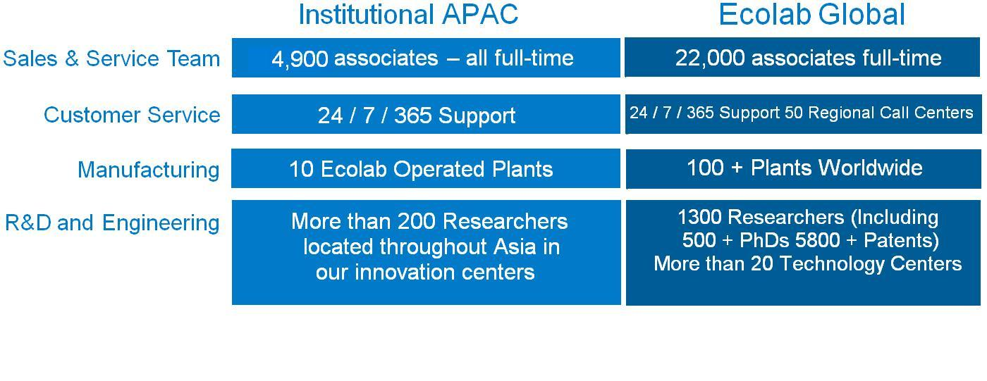

OUR OBJECTIVES

At Ecolab, we make it a priority to know the unique cleaning and maintenance needs of our customers business and we pride ourselves on delivering excellence. It’s why we offer customized products, programs and equipment backed by the industries largest and best-trained sales–and-service staff. It is also why we are the world leader in the development and marketing of innovative cleaning, sanitizing and maintenance products – and have been for almost 90 years.

We are dedicated to expanding our product offerings, safety and training features, thus significantly increasing our scope of specialist services to you - our valued business partner.
Ecolab’s objective is to provide Lugano Resort and Spa with Quality Products, Excellent Results and Consistent Service and Support at the very best possible cost hence our philosophy of “When you succeed we succeed”

ECOLAB INNOVATION LEADERSHIP

Best of the Class Technology Matters!

Ecolab is recognized as the best in industry by continuously launching best of the class innovation to help customers meet their emerging needs. Ecolab uses nothing but state of the art innovations focused at allowing you to run your business in the safest most efficient and effective manner, while helping your organization to become Cleaner, Safer, and Healthier in the process.

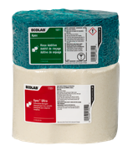
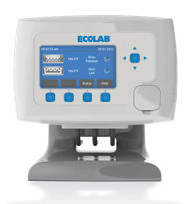
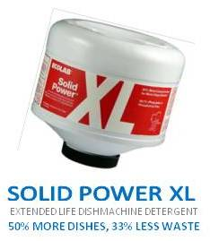
Some of the innovation available are:

- SMARTPOWER provides more power, with less waste. It is more sustainable than traditional product and reduces packaging waste by 99%. Solid form reduces waste and storage spec, prevents spillage and misuse.



- OASIS PRO: Ecolab offers the new line of Biodegradable housekeeping product “OASIS PRO” which is the much more concentrated and also the chemical container is lockable to prevent waste and misuse.

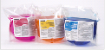

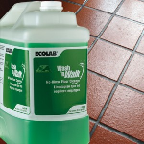

- Wash n Walk: Deep packed-in grease and soil build-up over time create “grease banks" and Wash ’n Walk attacks this grease to eliminate slippery floors. Wash ’n Walk reduces slips and falls, using cold water saves on energy and no rinse saves on water.

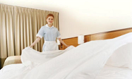

- AQUANOMIC is Ecolab’s latest low temperature laundry chemistry that achieves premium results with lower energy, water consumption. Laundry process is achieved while reducing temperatures a minimum of 25-30 degrees Celsius in wash wheel.

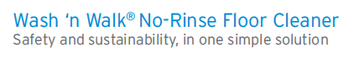
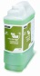

HELPING CONSERVE RESOURCES & REDUCE WASTE

Sustainability Matters!

- Our Solutions are proven to clean safely and reduce consumption of water, energy and packaging materials while protecting human health and ensuring safety.

- Up to 48%energy savings gained using innovative laundry programs which reduces wash cycle steps thus saving water and energy.

- Up to 46% water savings gained through advanced warewashing systems that monitor dishmachine use to lower rack counts and conserve utilities.

- Up to 98% less waste when concentrated housekeeping solutions are used which generate less plastic waste than ready-to-use products.

AWARDS & RECOGNITION
Global Leadership Matters!

For the sixth consecutive year, Ecolab was recognized by the Ethisphere Institute as one of the World’s Most Ethical Companies, rated on business ethics, corporate social responsibility, anti-corruption and sustainability.

The Carbon Disclosure Project selected Ecolab as one of only 11 companies in the 2011 Carbon Performance Leadership Index for efforts to mitigate climate change and to the Carbon Disclosure Leadership Index, recognizing commitment to strategy, governance, stakeholder communications and transparency in reporting sustainability practices.

Forbes magazine ranked Ecolab 28th on the World’s Most Innovative Companies list rating a company’s “innovation premium,” which measures the premium the stock market gives a company for anticipated/expected innovation.

Ecolab was named to the Dow Jones Sustainability (DJSI) World Index, a list of the world's leading sustainability companies, and to the DJSI North America Index. The DJSI World Index captures the top 10 percent of the world's 2,500 largest companies based on economic, environmental and social criteria. The North America Index captures the top 20 percent of the 600 largest companies in the United States and Canada.

Ecolab received the "Outstanding Contribution in Leading Food Safety Efforts and Driving Sustainability in China" award at the 2011 Food & Beverage Green Tech Asia Forum, held in Shanghai. The forum was organized by the Shanghai Food Association (SFA), a not-for-profit association for food safety professionals throughout the food supply chain industry. Ecolab was the only award recipient and was recognized for its outstanding achievements and contributions in both food safety and sustainability.

Ecolab received the New Cleanness Golden Award at the 2012 China International Cleaning Industry Expo for its leadership in the development of sustainable cleaning solutions for the Chinese.
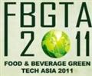
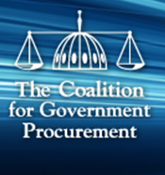
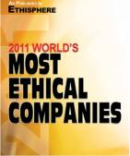
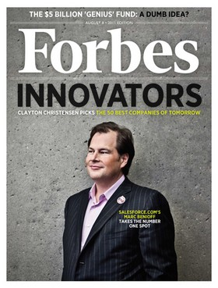

Sustainability and Food Safety Solutions Special
Contribution Awards

